NORTH SCARLE PARISH COUNCIL
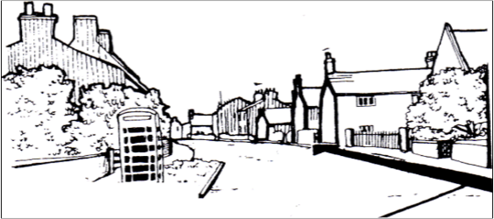  Chairman: Cllr David Jennings  Clerk: Hayley Broderick | PO Box 1344  Lincoln  LN5 5UE  Phone, Text, WhatsApp: 07907 328215  Email: northscarleparishcouncil@gmail.com  

April 2024

The Parish Council recently supported the installation of a sign indicating a Commonwealth War Grave in the cemetery. The grave is marked with a private, family memorial as opposed to a more recognisable white, Portland headstone and commemorates Arthur Wells. Details can be found at this link
https://www.cwgc.org/find-records/find-war-dead/search-results/?CemeteryExact=true&Cemetery=NORTH%20SCARLE%20CEMETERY

