NORTH SCARLE PARISH COUNCIL
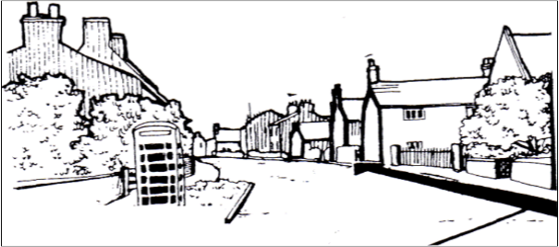  Chairman: Cllr David Jennings  Clerk: Hayley Broderick | PO Box 1344  Lincoln  LN5 5UE  Phone, Text, WhatsApp: 07907 328215  Email: northscarleparishcouncil@gmail.com  

North Scarle Parish Council is responsible for the allotments situated on Chapel Lane, North Scarle.

We have a waiting list for parishioners who are interested in using the allotment gardens. Please contact the Clerk to register your interest.

