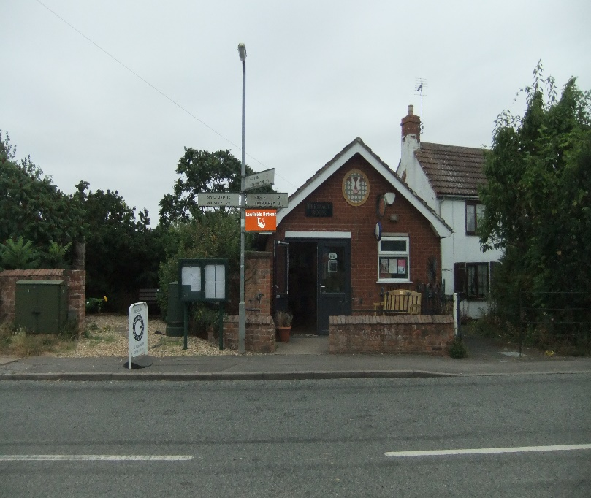

The Heritage Room, Chapel Lane, North Scarle, Lincoln, LN6 9EX.

Legionella Risk Assessment

In compliance with HSAW act, COSHH regulations & HSE ACOP L8 (The control of legionella bacteria in hot and cold-water systems}

Property Address | Chapel Lane North Scarle Lincoln LN6 9EX
Date of Assessment | 14 August 2024
Assessment carried out by: | William Tucker JP, MSc, BSc(hons), FIFireE CMIOSH, on behalf of North Scarle Parish Council

Describe the property type | Single storey brick building of traditional construction
Is there any tenant, resident or regular visitor  particularly susceptible to Legionella due to age, health or lifestyle? | The building is small, doubling up as the village Post Office and Heritage Room for the locals and visitors. The occupancy is based on a 5-yearly tenancy and is open to the public Monday to Friday 0900-1500 hrs. The maximum occupant capacity is 10 people, staffed by a single Post Mistress.  North Scarle Parish Council is the Landlord.  There is Low Risk susceptibility of the occupants from any Legionella bacteria minimized by weekly testing and flushing of the hot and cold supply to the electric wall water heater in the W.C. which is used solely by the Post Mistress. There is no significant risk to the public.
Describe the type of cold-water system e.g.  mains fed or from a storage tank. | The cold-water supply is fed directly to a thermostatically controlled water heater mounted on the wall above the sink in the WC.
Describe the type of hot water system, e.g. mains feed via combi boiler or from storage  tank. | No storage tanks are installed, the cold-water supply comes directly from the towns main serving the village.

Risk Categories

Water Outlet Temperature - (readings below were obtained by the Assessor with routine flushing and cleaning of hot and cold outlets verified by the Water Management Logbook held on-site)

Is cold water temperature at outlets below 20°C | Yes | 18.7 C
Is the hot water temperature above 50°C | Yes | 57,7 C

Defect/Risk | None noted at the time of the assessment and has been categorized as Low Risk
Recommendation | None
Responsible person: landlord/other | North Scarle Parish Council (as the Landlord) and the Post Mistress as the person with the day-to-day management of the building
- Cold water storage tanks

Is there one present? |  | No | N/A
Location | None present
Does it have a tight-fitting lid?
Is the water in the tank clean and free from rust, debris, scale and organic matter?
Is the temperature of the water in the tank
below 20°C?
Is the tank insulated?
If any debris, etc. is present in the system it should be drained and thoroughly cleaned. If debris is from corrosion on the tank itself then the tank may need to be replaced. All cold-water tanks should have tight fitting lids to prevent debris entering the system. The water in the tank should be below 20°C and the tank should be insulated to prevent the temperature rising above this level.
Identify any defect/risk and related recommendations associated with cold water storage. If any action is required identify responsible person:

Defect/Risk | N/A There is no cold-water storage involved
Recommendation | -
Responsible person: landlord/other | -

Hot water

Is the temperature setting on the wall mounted | Yes | Verified by testing during the assessment and inspecting the Water Management Logbook held on-site
water heater such that the hot water is
heated to a temperature above 50°C?
N.B. There is no hot water storage tank involved which would have a higher setting of 60°C.
NB: If the temperature is set at above 60°C this can cause scalding to users.
A yellow sticker affixed to the water heater warns users of the risk of exposure to hot water
Identify any defect/risk and related recommendations associated with hot water. If any action is required identify responsible person:

Defect/Risk | None noted
Recommendation | None
Responsible person: landlord/other | Landlord

Little used water outlets

Are there any water outlets that are used less  than once per week? | No
If yes, identify outlet and location: | N/A
Any little used outlets should be flushed through weekly by running water through the outlet for at least 2 minutes. Aerosol production should be minimised during this process by controlling the flow of water from the spout / cold water tap.
identify any risks and related recommendations associated with little used outlets. If any action is required identify responsible person:

Defect/Risk | None noted.
Recommendation | None
Responsible person: landlord/other | -

Shower heads

Are there any showers in the property? | No
If yes, identify location: | -
All shower heads should be cleaned, disinfected and descaled at least once every 6 months. Aerosol production should be minimised during this process.

Defect/Risk | N/A
Recommendation | None
Responsible person: landlord/other | -

Dead legs and redundant pipework
Sections of pipework are redundant or owing to the system design and have little/no through flow of water (known as “dead legs”) can allow water to stagnate in the system. Are there any dead legs known in the system? If so, please describe.

Are there any dead legs in the property? | No | None seen
If yes, identify location: | -

Any dead legs should be removed, or the system altered so that water flows through all pipework on a
regular basis.
Identify any risks and related recommendations associated with dead legs. If any action is required identify responsible person:

 | None
Recommendation | -
Responsible person: landlord/other | -

Unoccupied properties

Is the property left unoccupied for lengthy periods of time e.g. outwith statutory holidays? | No | -
During periods of un-occupancy all outlets on hot and cold-water systems should be flushed through at least once a week for at least 2 minutes. For long periods consider draining the system. Make sure that the system is flushed through when it is re-occupied by running all outlets for at least 2 minutes. Aerosol production should be minimised during this process by adjusting the flow through the outlets i.e. the spout and the cold tap.
Identify any risks and related recommendations associated with un-occupancy. if any action is required identify responsible person:

Defect/Risk | None noted
Recommendation | -
Responsible person: landlord/other | _

Advice to tenant including training

Has advice been given to the tenant as to the | Yes | Awareness training was given on issuing the Water Management Logbook and the Extech temperature tester in 2024
risks of Legionnaires Disease in a public building
and their responsibilities to minimize any residual risk?
This was facilitated by referring to the advice detailed in the Legionella Water Management Logbook issued to the tenant in the first quarter of 2024. This follows the latest HSE guidance on the control of Legionella bacteria. Refresher training in best practice will be given annually and whenever updates are necessary.
This assessment is complete and should be reviewed annually and when there is reason to suspect it is no longer valid. You should ensure that any recommendations above are implemented, and any existing controls maintained. Next scheduled review is 14th August 2025.

Signed 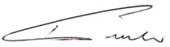  William Tucker | Date: | 14th August 2024
Notes page { delete as necessary)

