Regulatory Reform (Fire Safety) Order 2005 as amended by the Fire Safety Act 2021

Fire Risk Assessment for Small Premises (Heritage Room)

This form is a legal document intended to assist small businesses in conducting the fire risk assessment. It is suitable for use in simple premises, with a simple internal layout and small numbers of people present, e.g. small offices, shops, or industrial units and where people can escape unaided. In buildings with complicated escape arrangements, large numbers of people or high fire safety risk processes a more comprehensive fire safety risk assessment may be necessary.

The Fire Safety Action Plan at the end of this Fire Risk Assessment list what needs to be done by whom within a prioritised period. This should enable those responsible for implementing the findings to act without having to read the entire document.

The information below follows the UK Government’s simple 5 step guide to completing a suitable assessment. The fire safety risk assessment does not need to be complicated; it should be a common-sense review to identify the hazards (what could start a fire and what could burn), followed by consideration of the possible effects of a fire on people using the building. The important thing is that the fire risk assessment is systematic to ensure that every part of the premises is assessed. Every room, space, or area, especially those not often used, should be included.

If you identify any significant risks, you should consider if they can be reduced: first by removing the hazards and secondly by providing fire protection measures (e.g. a suitable means of raising an alarm of fire). These points should be addressed within the ‘What needs to be done to make each situation safe?’ section. If your premises are located within a larger building and if a fire in your business could affect your neighbours, you should share the findings of your fire risk assessment with them.

Whilst the fire regulation equally apply to small premises, the physical measures such as the provision of a hard wired fire alarm, fire extinguishers and fire evacuation drills must be propionate to the risk which means the sophistication of measures to protect the occupants from fire must be assessed ,the outcome does not necessarily mean excessive expenditure, e.g. an automatic fire detection and alarm system may be satisfied by Word of Mouth which is the case in relation to the Heritage Room as it is very small in area with a low number of occupants.

This fire risk assessment must be kept up to date. It is important to update the assessment if anything is changed that might affect the risk (e.g. new ignition sources or use of flammable liquids etc.). If you identify that either the likelihood of a fire occurring or there is a risk to people you may want to consider seeking further assistance.
Emergency Fire Plan

The findings of the fire risk assessment should be used to prepare an emergency fire plan. The fire plan for the Heritage Room is satisfied in the form of a Fire Action Notice displayed by the main exit door from the premises. This sets out to what the occupants must do in case of fire, the location of escape routes, how to raise the alarm, where to assemble on leaving the building and how to contact the Fire and Rescue Service. The fire safety equipment and any equipment that provides an ignition source (e.g. electrical appliances, etc.) should be regularly maintained to reduce the chance of fire and the risk to people. Frequent checks should also be made to make sure that the storage of materials, especially combustible materials such as the mail bags, paper, and cardboard, do not increase the risk of fire or prevent the use of escape routes. It is important that all members of staff know how to prevent fires and what to do if a fire does occur. To make sure that the emergency fire plan works regular fire drills/briefings should be conducted. In the case of small premises with less than 5 staff, a safety briefing should take place during the annual fire risk assessment review to refresh on the fire safety arrangements in place including how to use the portable fire extinguishers. If safe to do so. The above are legal requirements under the Regulatory Reform (Fire Safety) Order 2005 Further information and guidance on fire safety can be obtained from the author of this fire risk assessment.

The UK government’s 5 Step Guide to Fire Risk Assessment

- Identify the fire risks
- Identify people at risk
- Evaluate, remove, reduce, and protect from risk.
- Record, plan, inform, instruct and train
- Review.

The above steps formed the basis of a fire safety training briefing session following the physical inspection of the Heritage Room which will be reviewed annually.

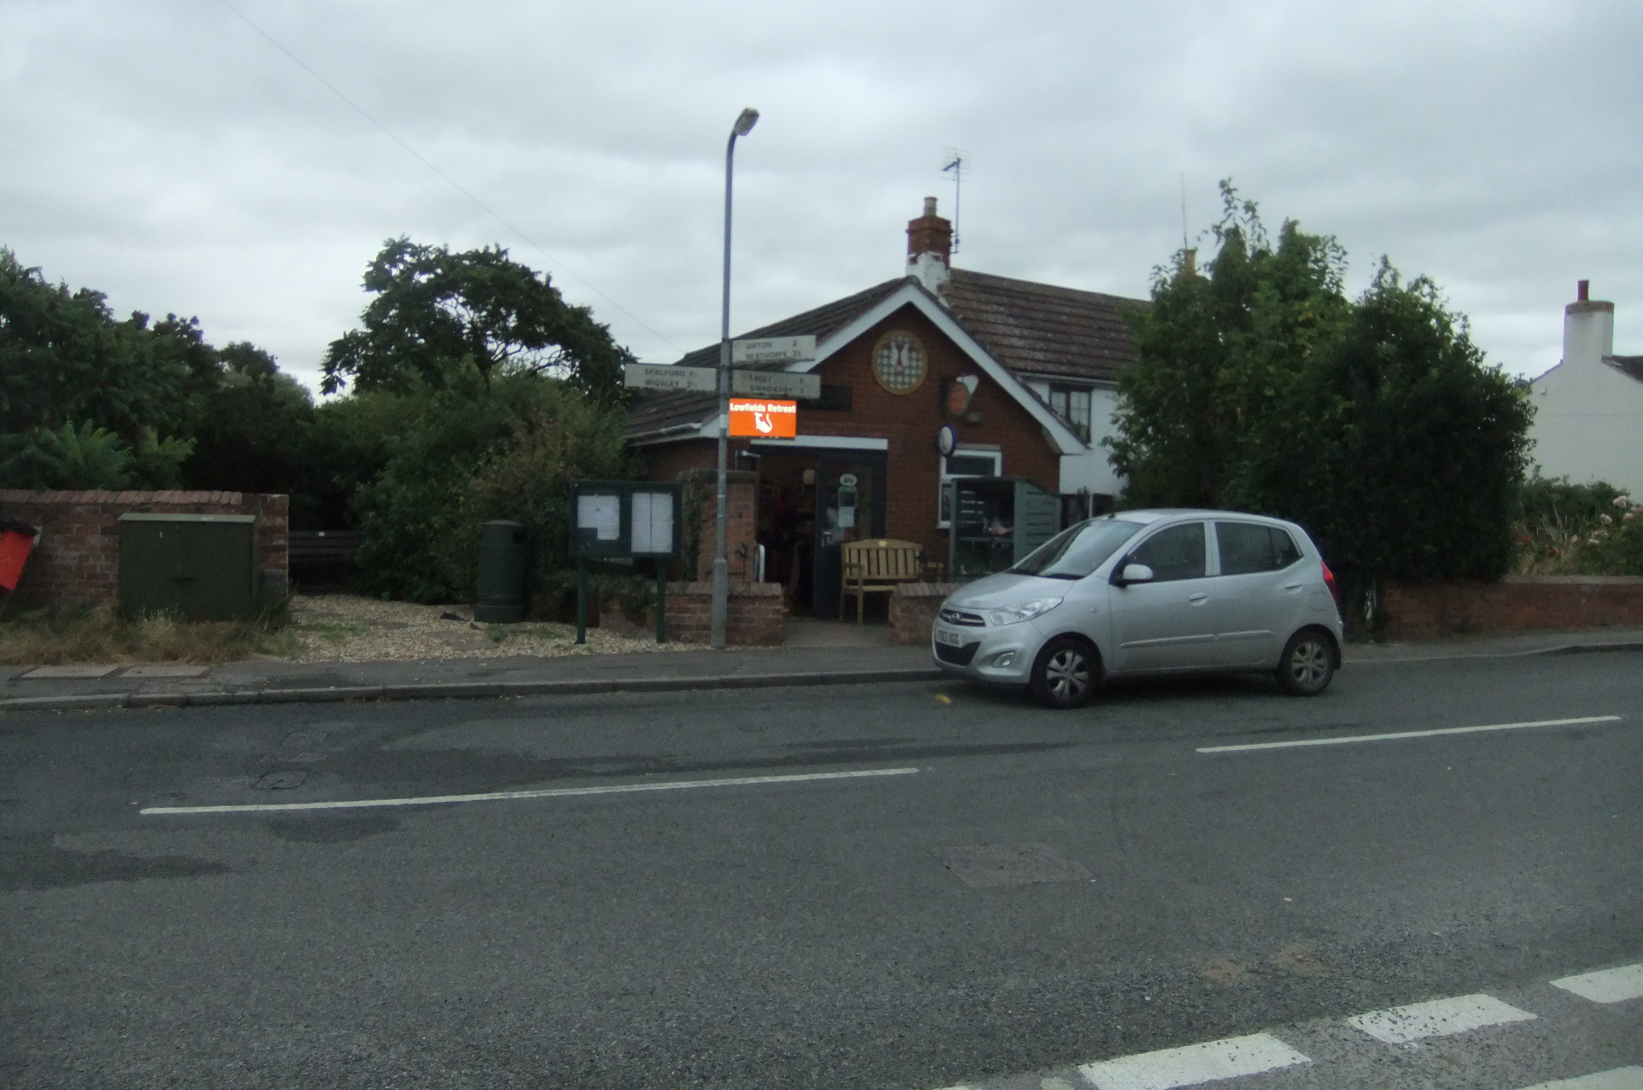

The Heritage Room, Chapel Lane, North Scarle, Lincoln, LN6 9EX.

FIRE RISK ASSESSMENT
DETAILS
Company Name: | North Scarle Parish Council
Premises Name: | The Heritage Room
Address: | 14, Chapel Lane, North Scarle, Lincoln, LN6 9EX.
Responsible Person: | Jules Loakes
Position: | Sub Post Mistress
Date of Assessment: | 28 August 2024
Conducted by: | William Tucker JP, MSc, BSc(hons), FIFireE CMIOSH, on behalf of North Scarle Parish Council
Position: | Fire Safety Consultant and Chartered Health and Safety Practitioner
Use of the Premises: | The Village Post Office within the Heritage Room
OCCUPANCY
Times in Use: |  |  | Weekdays: | 0900-1500 | Weekends: | Closed
Total Numbers of Staff: |  |  | Weekdays: | 1 | Weekends: | N/A
Total of all Persons Present: |  |  | Weekdays: | 10 | Weekends: | N/A
SIZE
Total size of premises (m²): |  |  | 16.8 m²
Number of Storeys: |  |  | Single storey
Number of Basements: |  |  | None

Step 1 - Identify Fire Hazards (Sources of Ignition)
Type |  | Location | Are existing control measures suitable?
Naked Flames |  | None seen- A No Smoking rule is in place. A No Smoking sign is on display. |  |  |  |  |  | N/A
Portable Heaters and Heating Equipment |  | No portable heaters seen. Electric wall heaters were noted but were switched off. No electrical hazards seen. |  |  |  |  |  | YES
Electrical Equipment |  | A few electrical items seen including a kettle, a free-standing chest freezer, and an upright fridge. There was no evidence of any misuse or faults visible. |  |  |  |  |  | YES
Cooking Equipment |  | None seen or in use. |  |  |  |  |  | N/A
Work Process Risk(s) |  | There was no works in progress at the time of the assessment. A contractors management system is in place by the Parish Council overseen by NKDC. Risk Assessments and Method Statements (RAMS) are requested from contractors where appropriate. Most works are overseen by NKDC. |  |  |  |  |  | YES
Arson |  | A risk of arson was identified from the indiscriminate discarding of a quantity of domestic waste at the rear and side walls of the Post Office. See photograph below. |  |  |  |  |  |  |  |  |  |  | NO
Smoking Materials |  | None seen in or around the periphery of the premises A No Smoking rule is in place with signage displayed. |  |  |  |  |  | YES
Other Sources  (including Contractors) |  | The 5 yearly testing and inspection of the fixed wiring and electrical installation is now due in accordance with BS7671. (IET Wiring Regulations). No contractor was on site at the time of the fire risk assessment |  |  |  |  |  |  |  |  |  |  | NO
 | If you have answered NO to any question above complete the details below: -
 | What needs to be done to make each situation safe? |  |  | Action required by whom |  |  | Date  due |  |  |  | Date  complete
 | - Remove the arson risk from the indiscriminate discarding of domestic waste to the rear and side walls of the Post Office. |  |  | Sub Post Mistress and/or neighbour to arrange for the discarded items to be removed. |  |  | To be done ASAP
 | - 5 yearly testing and inspection of the fixed wiring and electrical installation (due on the 7th August 2024) in accordance with BS7671. |  |  | Landlord (North Scarle Parish Council)) |  |  | August 2024 (in hand)

Step 1 – Identify Fire Hazards (Sources of Fuel and Oxygen)
Type |  |  | Location |  | Are existing control measures suitable?
Wood / Paper /Cardboard |  | Discarded combustible waste seen at the rear and side of the building. See action above. |  |  |  |  |  |  |  |  |  |  |  |  | NO
Plastics / Rubber / Foam |  | As above |  |  |  |  |  |  |  |  |  |  |  |  | NO
Retail Stock |  | No excessive waste from the retail stock was seen at the time of the assessment. |  |  |  |  |  |  |  | YES
Furniture and Fixings  (curtains, blinds etc) |  | A discarded door was included in the waste items seen at the external rear of the Post Office. |  |  |  |  |  |  |  |  |  |  |  |  | NO
Flammable Material  (gases / liquids / paints / thinners / glues) |  | A green plastic petrol container was seen on top of the discarded waste items at the external rear of the Post Office. |  |  |  |  |  |  |  |  |  |  |  |  | NO
Display Materials or Decorations |  | None seen from the Retail side of the business |  |  |  |  |  |  |  | YES
Waste Materials  (refuse, packaging) |  | The Sub Postmistress advised that she takes general waste home to be disposed of by the Council Refuse collection service. |  |  |  |  |  |  |  | YES
Building Structure |  | No hazard emanating from the buildings structure |  |  |  |  |  |  |  | YES
Oxygen Supplies  (air conditioning units / bottles / piped supply) |  | None seen and no air conditioning installed or required. |  |  |  |  |  |  |  | N/A
 | If you have answered NO to any question above complete the details below: -
 | What needs to be done to make each situation safe? |  |  |  |  | Action required by whom |  |  | Date  due |  |  |  | Date  complete
 | - All the fire hazards seen were external to the property from discarded waste. See photo below |  |  |  |  | Sub Postmistress and/or neighbour to arrange for the discarded items to be removed. See below |  |  | To be resolved ASAP |  |  |  | See Fire Safety Action Plan below

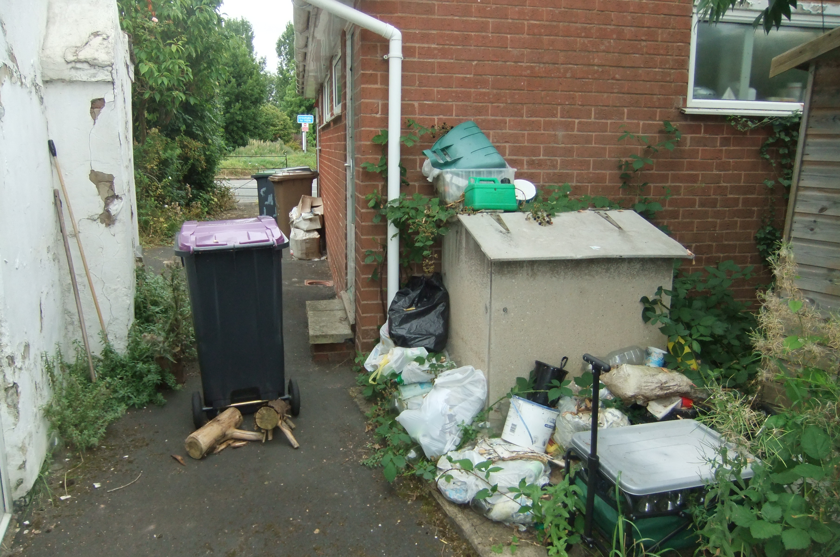

Discarded waste at the rear and side of The Heritage Room which is vulnerable to an arson attack and will attract rodents.

Step 2 – Identifying People at Risk

Type |  | Findings
- Sensory Risk:  People with visual and / or hearing impairment(s) |  | The Heritage Room accommodates the village Post Office which from observation experiences a trickle of public attending to use its service and/or to purchase essential items from the small retail facility.  The village Post Office is used by all ages some of whom may have sensory impairment. Access to the building is off the pavement and on a flat surface. The opening times are 0900-1500 which is in daylight hours.
- Mobility Risk:  People with physical impairments |  | Good access is afforded to anyone with a physical impairment with double leaf outward opening exit doors leading directly to the pavement at street level.  The exit doors have an unimpeded width of 66cm when fully opened which will facilitate safe egress for wheelchair users.
- Familiarity Risk:  People who may be new to the premises and not familiar to its layout, seasonal workers, contractors, visitors, or customers |  | The building is small and not complex to use regardless of familiarity.  The internal layout is easy of open plan design and visible to the Post Mistress who has an unobstructed view of all areas used by the public and contractors.  Travel distance from the back wall to the double leaf exit doors to the street is less than 6.1m. The time taken to exit the building in a fire emergency would be under half a minute which is well within acceptable limits.
- Numbers Risk:  Large numbers of people, small numbers of disabled people |  | The average maximum occupant level at peak times is 10 (verified by the Post Mistress). The low number of occupants makes for a safe exit in a fire emergency.
- Lone Workers / People Working in Isolation / Others |  | A panic alarm linked to an alarm receiving centre is located within the inner room of the Post Office which is single staffed. The Post Office as the employer is responsible for producing a Lone Working Risk Assessment

Additional Information:

That Actions raised above are considered reasonable and proportionate to the risk level and have been assigned as Low Risk.

The Post Office as the employer must conduct a risk assessment of lone working activities. In addition, If more than 5 people are employed, then by law this risk assessment and risks of lone working must be recorded.

The Post Office is solely responsible for the security of the inner room which was outside the brief of this fire risk assessment.

Step 3 ~ Evaluate, Remove, Reduce and Protect from Risk
Are ignition sources controlled to reduce the chances of fire? |  |  |  |  |  |  |  |  |  |  |  |  |  | NO
Are combustible materials kept away from ignition sources? |  |  |  |  |  |  |  |  |  |  |  |  |  | NO
Are all windows and openings closed last thing at night? |  |  |  |  |  |  | YES
Is your fire alarm system adequate for your premises? |  |  |  |  |  |  | YES
Will everybody be warned if the fire alarm operates? |  |  |  |  |  |  | YES
Can everyone escape without assistance? |  |  |  |  |  |  | YES
Is the means of escape adequate for the layout of the building? |  |  |  |  |  |  | YES
Are all fire exits easily identified by correct signage? |  |  |  |  |  |  | YES
Are escape routes free from obstruction and storage? |  |  |  |  |  |  | YES
Are all doors on escape routes easily opened without a key? |  |  |  |  |  |  | YES
Do all doors on escape routes open in the direction of escape? |  |  |  |  |  |  | YES
Can everyone escape in a reasonable time? |  |  |  |  |  |  | YES
Are escape routes adequately lit if the regular lighting system fails? |  |  |  |  |  |  | YES
Is the lighting adequate to illuminate circulation routes? |  |  |  |  |  |  | YES
Do you have fire fighting equipment? |  |  |  |  |  |  | YES
Is the fire fighting equipment adequate for the risks present? |  |  |  |  |  |  | YES
Are housekeeping and general waste management adequate? |  |  |  |  |  |  |  |  |  |  |  |  |  | NO
Are security arrangements sufficient to prevent unauthorised access? |  |  |  |  |  |  | YES
Are measures adequate to prevent the incidents of arson? |  |  |  |  |  |  |  |  |  |  |  |  |  | NO
Are your premises free of any large open roof spaces or concealed ceiling voids? |  |  |  |  |  |  | YES
Would a fire in your premises be contained within it? |  |  |  |  |  |  | YES
Can the fire service easily get to your premises? |  |  |  |  |  |  | YES
 | If you have answered NO to any question above complete the details below: -
 | What needs to be done to make each situation safe? |  | Action required by whom |  |  |  |  | Date  due |  |  |  |  | Date  complete
 | - As per Step 1 above All the fire hazards seen were external to the property from discarded combustible waste. |  | Sub Post Mistress and/or neighbour to arrange for the discarded items to be removed. |  |  |  |  | To be done ASAP
Step 4 ~ Record, Plan, Inform, Instruct and Train
You must record your fire safety arrangements – this includes:
Have you made an Emergency Fire Plan? |  |  |  |  |  |  |  |  |  | YES
Have you provided fire instruction and staff training? |  |  |  |  |  |  |  |  |  | YES
Are there records of fire drills to evaluate your training and emergency plan? |  |  |  |  |  |  |  |  |  | YES
Are there records of maintenance on all fire safety measures? |  |  |  |  |  |  |  |  |  |  |  |  |  |  | NO
Have you recorded the significant findings of this assessment on Page 9? |  |  |  |  |  |  |  |  |  | YES
 | If you have answered NO to any question above complete the details below: -
 | What needs to be done to make each situation safe? |  | Implement the actions detailed in the Fire Safety Action Plan below. |  |  |  |  | Implement the Actions in the time detailed in the Fire Safety Action Plan below. |  |  |  |  | Date  Complete to be recorded in the Fire Safety Action Plan below.
 | - A Fire Emergency Plan was produced by the Assessor in the form of a Fire Action Notice and displayed by the main exit doors from the Heritage Room |  | No fire drills are necessary for such a small premises with only one employee. A refresh of the Emergency Fire Plan will be undertaken annually along with the Fire Risk Assessment |  |  |  |  | 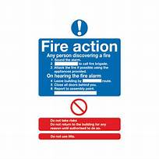
 | - The 5 yearly testing and inspection of the fixed wiring and electrical installation and the annual servicing and relocation of the two fire extinguishers are required |  | Included in the Fire Safety Action Plan below |  |  |  |  | Parish Clerk to deal
Step 5 ~ Review
Your fire safety risk assessment must be kept up to date
Date of next review  It is recommended that you review your fire risk assessment regularly (recommended every 12 months) OR if you make changes to the layout of your premises, any changes to work processes, significantly increase the amount of combustible materials stored or displayed or sources of ignition, change your opening hours (e.g. to include night time opening etc.) or any failures in your fire safety precautions then you should review your fire risk assessment sooner. |  |  |  |  |  |  |  |  | 22/ 08 / 2025

For further information on Fire Safety visit the Lincolnshire Fire and Rescue Service website.

SIMPLE PREMISES FIRE RISK ASSESSMENT

LEVEL OF FIRE RISK

In premises where there is a likelihood of a fire starting and spreading quickly, or a fire could start and grow undetected, and affecting the escape routes before people can use them, then the level of risk should normally be regarded as ‘higher’. Such premises might include those where significant quantities of flammable materials are used or stored; ready sources of ignition are present, e.g. heat producing machinery and processes; premises where significant numbers of the people are present and might move slowly or be unable to move without assistance; and premises where the construction provides hidden voids or flues through which a fire could quickly spread.

In premises where there is a low occupancy level and all the occupants are able bodied and capable of using the means of escape without assistance; very little chance of a fire starting; few if any highly combustible or flammable materials or other fuels for a fire; fire is unlikely to spread quickly; and will be quickly detected so that all people will quickly know that a fire has occurred and can make their escape, then the risk can usually be regarded as ‘lower’.

In most cases, however, the risk will usually be ‘normal’.

Considering both the active and passive fire prevention measures and general fire precautions observed at the time of this fire safety risk assessment, it is considered that the hazard from fire (likelihood of fire) at these premises is:

Low | X |  | Normal |  |  | High

In this context, a definition of the above terms is as follows: -

Low: Unusually low likelihood of fire because of negligible potential sources of ignition.

Normal: Normal fire hazards (e.g. potential ignition sources) for this type of occupancy, with fire hazards subject to appropriate controls.

High: Lack of adequate controls applied to one or more significant fire hazards, such as to result in significant increase in the likelihood of fire.

Note that, although the purpose of the above is to place the risk fire in context, the approach to fire risk assessment is subjective and for guidance only. All hazards and deficiencies identified in this fire risk assessment should be addressed by implementing all the recommendations contained in the following action plan.

FIRE SAFETY ACTION PLAN

Each item below has been allocated a priority as follows: -
Priority 1: | Needs attention immediately
Priority 2: | Needs attention within 1 month
Priority 3: | Needs attention within the next 6 months
Priority 4: | Needs attention within the next 12 months

Ref: | Action  Required | Priority |  | Action by  Whom |  | Completion  Date
Step 1 | Provide and display a Fire Emergency Plan (Fire Action Notice) at the main exit doors from the Post Office. See photo below | 1 |  | Sub Post mistress |  | Resolved by the consultant during the assessment
Step 1 | Remove the external waste items discarded at the side and rear of the Post Office (vulnerable to an arson attack and rodents. | 2 |  | Landlord & the occupants of the neighbouring property |  | Hayley to discuss with the PC Chair and Jules to resolve.
Step1 | The 5 yearly testing and inspection of the fixed wiring and electrical installation (due on the 7th August 2024) in accordance with BS7671. | 2 |  | Landlord |  | The Parish Clerk conformed this is in hand
Step 2 | Arrange for annual servicing of the two fire extinguishers by a BAFE registered company. Relocate the CO2 by the distribution board by the exit doors and the 3l water type by the side door. Replace with a 9l equivalent. Both to be on suitable wall brackets with the appropriate fluorescent instruction cards to BS5306. | 2 |  | Landlord |  | The Parish Clerk to arrange
Step 3 | Repair the wooden threshold bar of the side access door which has rotted with weathering and ensure the door can be easily locked opened from the inside. | 3 |  | Landlord |  | The Parish Clerk to check progress with NKDC who have inspected.it.

Emergency Fire Plan (Fire Action Notice) for the Heritage Room (The village Post Office)

1.On discovery of a fire Dial 999. Do not tackle the fire- shut it in

2.On hearing the fire alarm (by Word of Mouth) – leave by the main entrance doors.

3. Proceed to the Fire Assembly Point (the grassed area next to the Pumping Station on Chapel Lane and await instructions. Do NOT re-enter the building

